Resa Mumbai Thivim

Färdplan
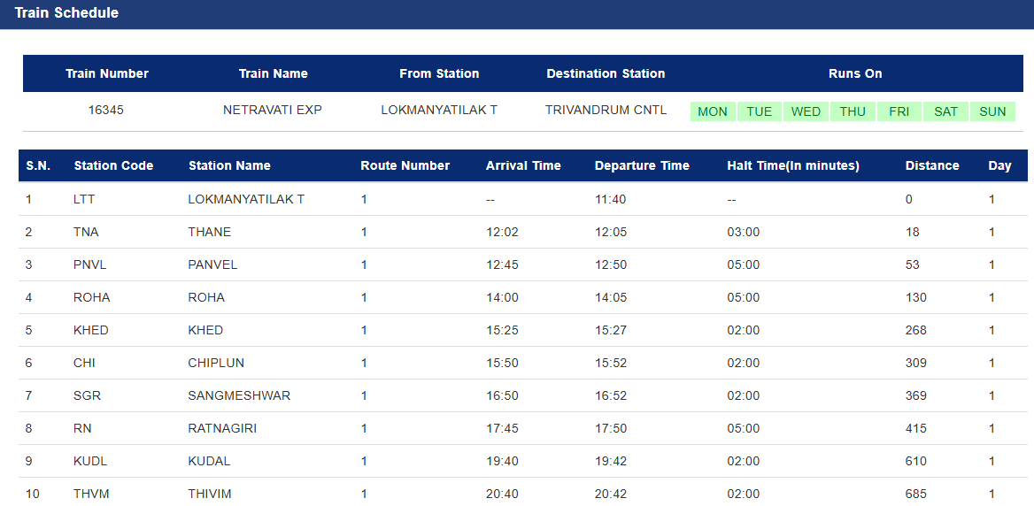

https://contents.irctc.co.in/en/ForeignTouristQuotaBooking.pdf

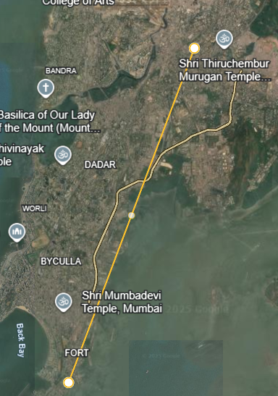
Taj Mahal Hotel, Mumbai,
PJ Ramchandani Marg, Apollo Bandar, Colaba, Bombay
LokmanyaTilak T,
Pipeline Road, Tilak Nagar, Kurla, Bombay

